Programming 6212 Part 3
St 10456326
PROG6212-POE Part Three
  - Lecturer Feedback

- Lecturer: “I cannot approve or reject as the buttons did not show on my side”.
- Lecturer: “Can be more descriptive”.
- Lecturer: “No secure upload attempt.”

  - Unit Testing
Claim Controller Test
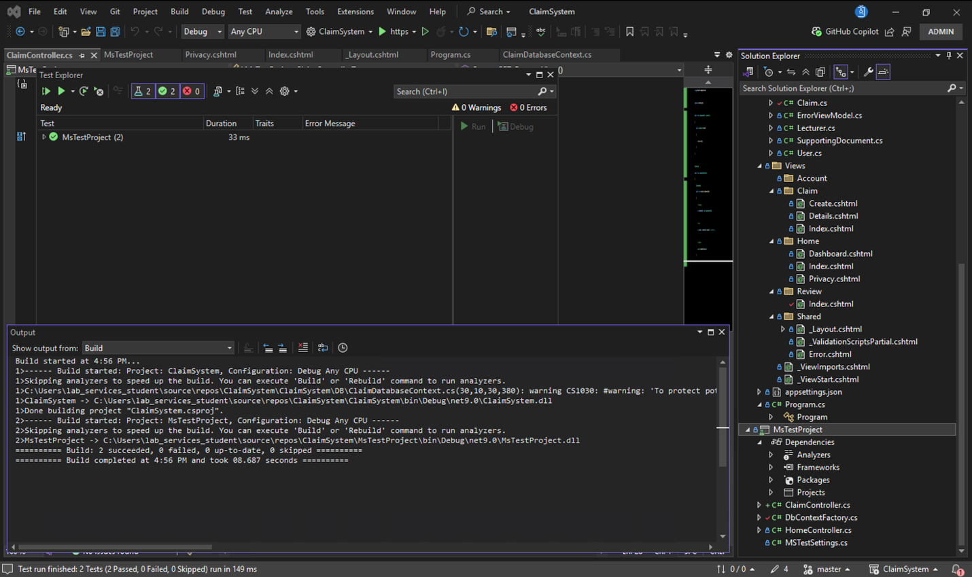

Review Controller Test
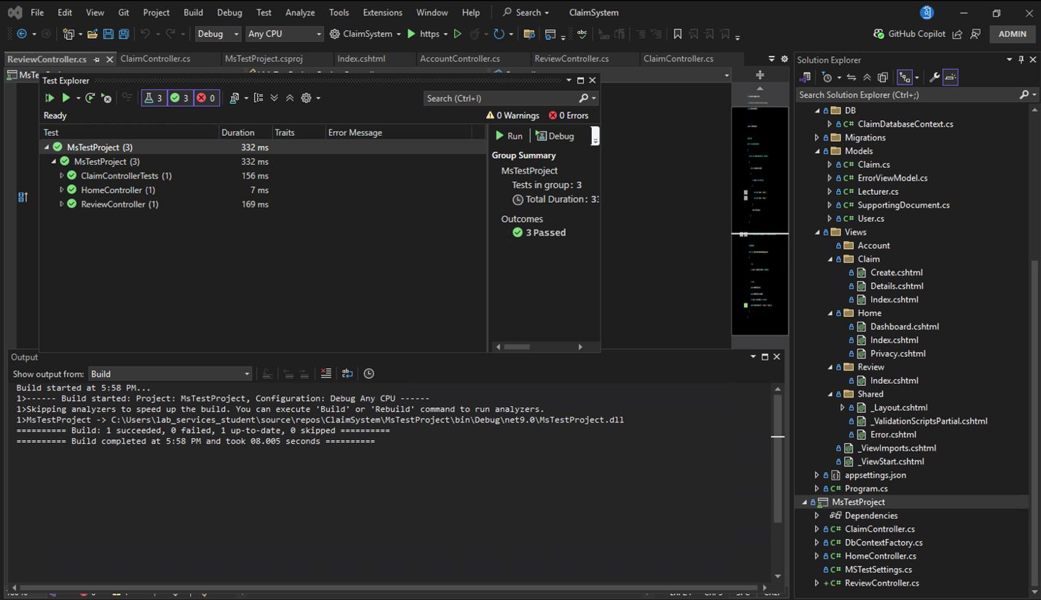
Home Controller Test
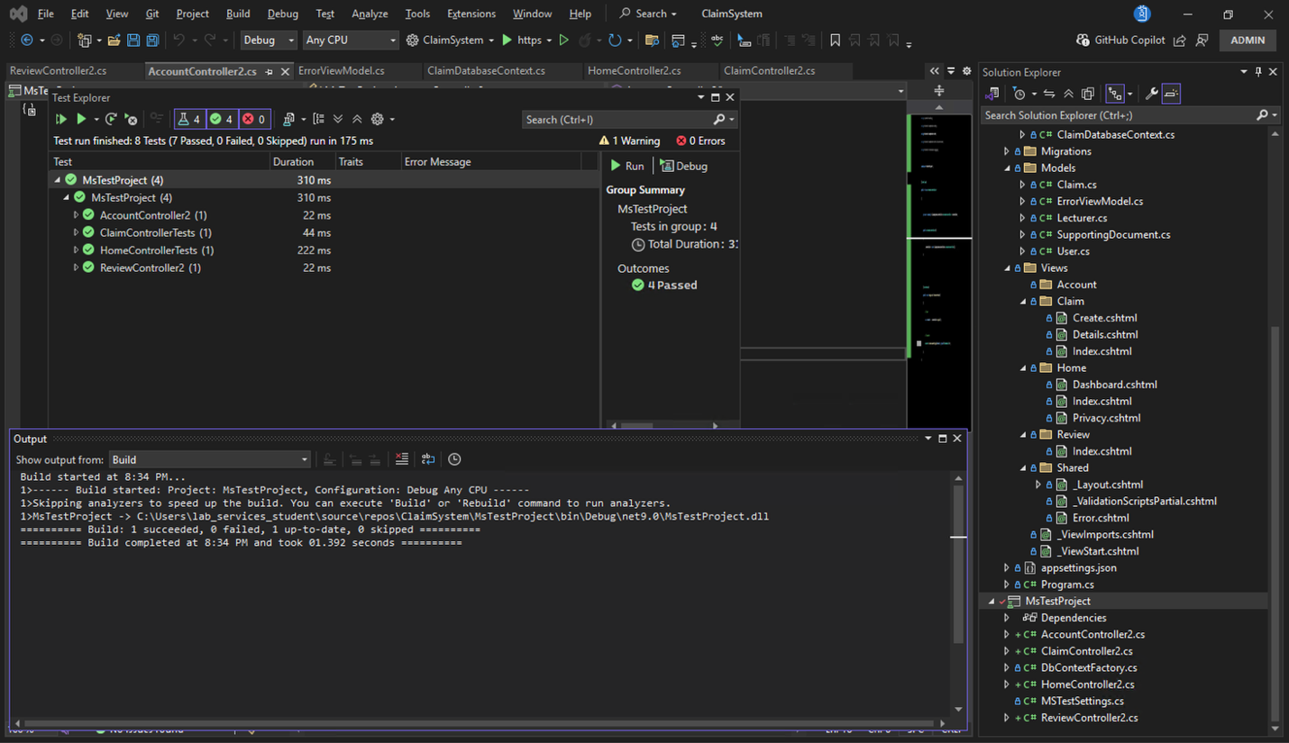

Account Controller Test

Database s
CREATE TABLE dbo.[User](
UserId INT IDENTITY(1,1) PRIMARY KEY,
Username NVARCHAR(50) NOT NULL UNIQUE,
PasswordHash NVARCHAR(255) NOT NULL,
Email NVARCHAR(255) NOT NULL UNIQUE,
Role NVARCHAR(100) NOT NULL
CHECK(Role IN('Lecturer','Academic Coordinator','Program Manager','HR')),
IsActive BIT NOT NULL DEFAULT 1
);

CREATE TABLE dbo.Lecturer(
LecturerId INT IDENTITY(1,1) PRIMARY KEY,
UserId INT NOT NULL UNIQUE,
Name NVARCHAR(50) NOT NULL,
Department NVARCHAR(100) NOT NULL,
PhoneNumber NVARCHAR(30) NULL,
Address NVARCHAR(200) NULL,
CONSTRAINT FK_Lecturer_User
FOREIGN KEY(UserId) REFERENCES dbo.[User](UserId) ON DELETE CASCADE
);

CREATE TABLE dbo.HR(
HRId INT IDENTITY(1,1) PRIMARY KEY,
UserId INT NOT NULL UNIQUE,
Name NVARCHAR(50) NOT NULL,
Department NVARCHAR(100) NOT NULL,
PhoneNumber NVARCHAR(30) NULL,
CONSTRAINT FK_HR_User
FOREIGN KEY(UserId) REFERENCES dbo.[User](UserId) ON DELETE CASCADE
);

CREATE TABLE dbo.Claim(
ClaimId INT IDENTITY(1,1) PRIMARY KEY,
ClaimNumber NVARCHAR(20) NOT NULL UNIQUE,
LecturerId INT NOT NULL,
MonthClaim NVARCHAR(20) NOT NULL,
HoursWorked DECIMAL(10,2) NOT NULL,
AmountPerHour DECIMAL(10,2) NOT NULL,
TotalAmount DECIMAL(21,4) NULL,
Status NVARCHAR(30) NOT NULL DEFAULT 'Pending',
DateSubmitted DATETIME NOT NULL DEFAULT GETDATE(),
LastUpdatedDate DATETIME NOT NULL DEFAULT GETDATE(),
AdditionalNotes NVARCHAR(500) NULL,
CONSTRAINT CK_Claim_Positive
CHECK(HoursWorked>=0 AND AmountPerHour>=0),
CONSTRAINT FK_Claim_Lecturer
FOREIGN KEY(LecturerId) REFERENCES dbo.Lecturer(LecturerId) ON DELETE CASCADE
);

CREATE TABLE dbo.ClaimApproval(
ClaimApprovalId INT IDENTITY(1,1) PRIMARY KEY,
ClaimId INT NOT NULL,
UserId INT NOT NULL,
ApprovalDate DATETIME NOT NULL DEFAULT GETDATE(),
Role NVARCHAR(30) NOT NULL,
Action NVARCHAR(20) NULL,
Status NVARCHAR(30) NOT NULL,
Comments NVARCHAR(500) NULL,
CONSTRAINT FK_ClaimApproval_Claim
FOREIGN KEY(ClaimId) REFERENCES dbo.Claim(ClaimId) ON DELETE CASCADE,
CONSTRAINT FK_ClaimApproval_User
FOREIGN KEY(UserId) REFERENCES dbo.[User](UserId)
);

CREATE TABLE dbo.SupportingDocument(
SupportingDocumentId INT IDENTITY(1,1) PRIMARY KEY,
ClaimId INT NOT NULL,
FileContent VARBINARY(MAX) NOT NULL,
FileName NVARCHAR(100) NOT NULL,
FileSize BIGINT NOT NULL DEFAULT 0,
ContentType NVARCHAR(100) NOT NULL DEFAULT 'application/octet-stream',
FileUploadDate DATETIME NOT NULL DEFAULT GETDATE(),
FilePath NVARCHAR(255) NOT NULL,
Description NVARCHAR(500) NULL,
CONSTRAINT FK_SupportingDocument_Claim
FOREIGN KEY(ClaimId) REFERENCES dbo.Claim(ClaimId) ON DELETE CASCADE
);
THE MAIN MODELS IN MY DATABASE ARE ABOVE BUT I DO HAVE ANOTHER MODELS LIKE DASHBOARD VIEW MODEL, LECTURER VIEW MODEL, PASSWORDHELP AND USERMANAGEMENT VIEW MODEL. I DIDN’T KNOW IF THEY SHOULD HAVE BEEN ADDED TO DB HERE THERE ARE:
VIEWS AND FUNCTIONS
-- Password Helper Functions (SQL Implementation)
CREATE FUNCTION dbo.HashPassword(@password NVARCHAR(255))
RETURNS NVARCHAR(255)
AS
BEGIN
DECLARE @hashedPassword NVARCHAR(255);
SET @hashedPassword = CONVERT(NVARCHAR(255), HASHBYTES('SHA2_256', @password), 2);
RETURN @hashedPassword;
END;

CREATE FUNCTION dbo.VerifyPassword(@enteredPassword NVARCHAR(255), @storedHash NVARCHAR(255))
RETURNS BIT
AS
BEGIN
DECLARE @hashedEnteredPassword NVARCHAR(255);
SET @hashedEnteredPassword = dbo.HashPassword(@enteredPassword);

IF @hashedEnteredPassword = @storedHash
RETURN 1;
RETURN 0;
END;

-- Stored Procedures for User Management
CREATE PROCEDURE dbo.CreateUserWithLecturer
@Name NVARCHAR(50),
@Department NVARCHAR(100),
@Email NVARCHAR(255),
@PhoneNumber NVARCHAR(30) = NULL,
@Address NVARCHAR(200) = NULL,
@Role NVARCHAR(100) = 'Lecturer',
@Password NVARCHAR(255),
@UserId INT OUTPUT,
@LecturerId INT OUTPUT
AS
BEGIN
BEGIN TRANSACTION;
BEGIN TRY
-- Create User
INSERT INTO dbo.[User] (Username, PasswordHash, Email, Role, IsActive)
VALUES (@Email, dbo.HashPassword(@Password), @Email, @Role, 1);

SET @UserId = SCOPE_IDENTITY();

-- Create Lecturer
INSERT INTO dbo.Lecturer (UserId, Name, Department, PhoneNumber, Address)
VALUES (@UserId, @Name, @Department, @PhoneNumber, @Address);

SET @LecturerId = SCOPE_IDENTITY();

COMMIT TRANSACTION;
END TRY
BEGIN CATCH
ROLLBACK TRANSACTION;
THROW;
END TRY
END;

-- View for Dashboard Statistics
CREATE VIEW dbo.DashboardStatistics
AS
SELECT
(SELECT COUNT(*) FROM dbo.Claim) AS TotalClaims,
(SELECT COUNT(*) FROM dbo.Claim WHERE Status = 'Pending') AS PendingClaims,
(SELECT COUNT(*) FROM dbo.Claim WHERE Status = 'Coordinator Approved') AS CoordinatorApprovedClaims,
(SELECT COUNT(*) FROM dbo.Claim WHERE Status = 'Fully Approved') AS FullyApprovedClaims,
(SELECT COUNT(*) FROM dbo.Claim WHERE Status = 'Rejected') AS RejectedClaims,
(SELECT COUNT(*) FROM dbo.[User] WHERE Role = 'Lecturer' AND IsActive = 1) AS ActiveLecturers,
(SELECT COUNT(*) FROM dbo.[User] WHERE Role = 'Academic Coordinator' AND IsActive = 1) AS Coordinators,
(SELECT COUNT(*) FROM dbo.[User] WHERE Role = 'Program Manager' AND IsActive = 1) AS Managers;

-- View for User Management
CREATE VIEW dbo.UserManagementView
AS
SELECT
u.UserId,
u.Email,
u.Role,
u.IsActive,
COALESCE(l.Name, h.Name) AS Name,
COALESCE(l.Department, h.Department) AS Department,
l.LecturerId,
h.HRId
FROM dbo.[User] u
LEFT JOIN dbo.Lecturer l ON u.UserId = l.UserId
LEFT JOIN dbo.HR h ON u.UserId = h.UserId
WHERE u.Role IN ('Lecturer', 'Academic Coordinator', 'Program Manager', 'HR');

-- View for Recent Claims (for Dashboard)
CREATE VIEW dbo.RecentClaimsView
AS
SELECT TOP 10
c.ClaimId,
c.ClaimNumber,
c.Status,
c.DateSubmitted,
c.TotalAmount,
l.Name AS LecturerName,
l.Department
FROM dbo.Claim c
INNER JOIN dbo.Lecturer l ON c.LecturerId = l.LecturerId
ORDER BY c.DateSubmitted DESC;

-- Indexes for better performance
CREATE INDEX IX_Claim_Status ON dbo.Claim(Status);
CREATE INDEX IX_Claim_DateSubmitted ON dbo.Claim(DateSubmitted);
CREATE INDEX IX_Claim_LecturerId ON dbo.Claim(LecturerId);
CREATE INDEX IX_User_Email ON dbo.[User](Email);
CREATE INDEX IX_User_Role ON dbo.[User](Role);
CREATE INDEX IX_ClaimApproval_ClaimId ON dbo.ClaimApproval(ClaimId);
CREATE INDEX IX_SupportingDocument_ClaimId ON dbo.SupportingDocument(ClaimId);

-- Sample Data for Testing
INSERT INTO dbo.[User] (Username, PasswordHash, Email, Role, IsActive)
VALUES
('admin@university.com', dbo.HashPassword('admin123'), 'admin@university.com', 'Academic Coordinator', 1),
('manager@university.com', dbo.HashPassword('manager123'), 'manager@university.com', 'Program Manager', 1),
('hr@university.com', dbo.HashPassword('hr123'), 'hr@university.com', 'HR', 1);

DECLARE @AdminId INT, @ManagerId INT, @HRId INT;
SELECT @AdminId = UserId FROM dbo.[User] WHERE Email = 'admin@university.com';
SELECT @ManagerId = UserId FROM dbo.[User] WHERE Email = 'manager@university.com';
SELECT @HRId = UserId FROM dbo.[User] WHERE Email = 'hr@university.com';

INSERT INTO dbo.Lecturer (UserId, Name, Department, PhoneNumber, Address)
VALUES
(@AdminId, 'Dr. Admin User', 'Computer Science', '123-456-7890', 'University Campus'),
(@ManagerId, 'Dr. Manager User', 'Mathematics', '123-456-7891', 'University Campus');

INSERT INTO dbo.HR (UserId, Name, Department, PhoneNumber)
VALUES
(@HRId, 'HR Officer', 'Human Resources', '123-456-7892');

